Veteran Health Care Application  
Form 10-10EZ

VA.gov - Online 10-10EZ screen walkthrough

Created: 08/2025

# Health Care Application Overview and Navigation

VA.gov users can apply for health care benefits by filling out the online application (VA form 10-10EZ) at https://www.va.gov/health-care/apply-for-health-care-form-10-10ez/introduction.

# Health Care Application Introduction Page

Currently, the Health Care Application is available on VA.gov (https://www.va.gov/health-care/apply-for-health-care-form-10-10ez/introduction) to all users who come to the site, whether they are signed in or signed out.

## Signed out users

Signed out application introduction page: https://www.va.gov/health-care/apply-for-health-care-form-10-10ez/introduction.

Signed-out users will access the health care application through the health care application introduction page.

On this page, we strongly encourage people to log in before applying.

Signed-out users can access the health care application. They can do so through a screener ID page where their entered personal information is used to scan the VA.gov system for existing records. They are shown the screener ID page immediately upon clicking “Start your application without signing in.”

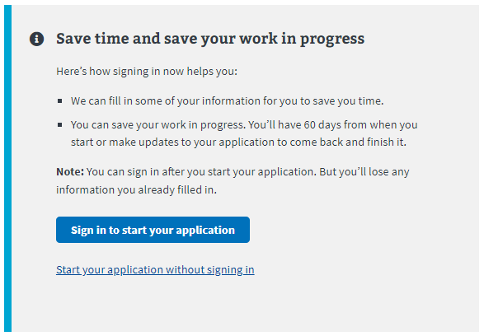

The screener ID page asks them for their first and last name, date of birth (DOB), and Social Security number (Social Security number).

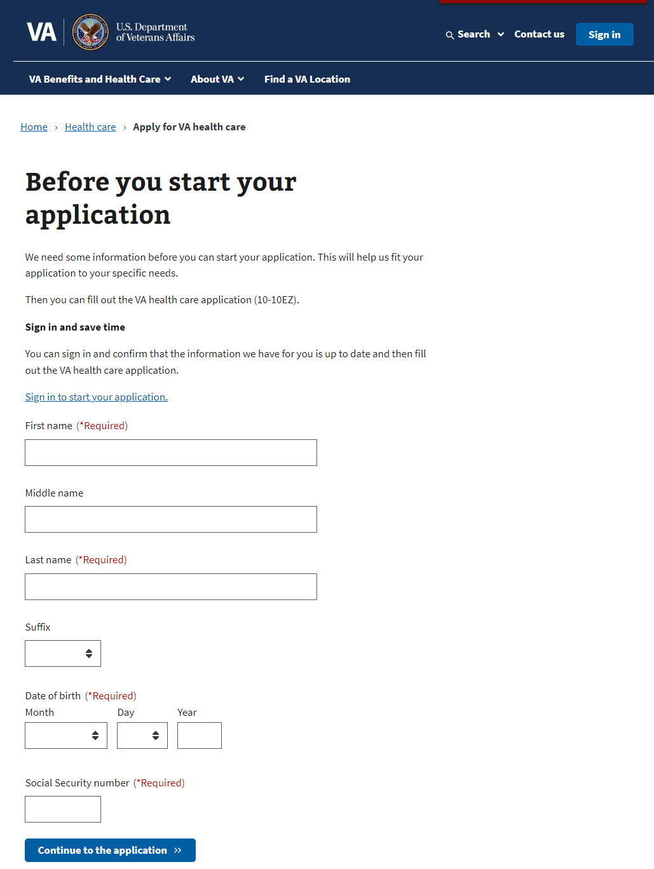

Upon filling out the ID page screener and pushing the “Continue to the application” button, users found in the VA.gov system will see the following alert that directs them to sign in to continue. They won’t be able to complete the application until they do:

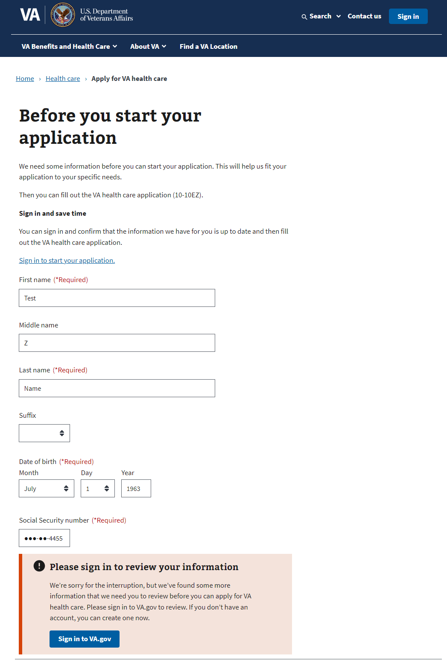

# Filling Out the Health Care Application

There are 6 sections in the health care application, but not everyone is shown the entire application:

1. Veteran information
2. VA benefits
3. Military service
4. Household information
5. Insurance information
6. Application review

**Some users can fill out a shortened application version by skipping some sections.** Veterans with a disability rating of equal to or greater than 50 percent will be shown the shortened form.

Please note: The system will prefill the information we already have on file for authenticated users. Users can review and update some of this as they complete the application.

Each section has multiple pages of questions that the user must enter to complete the application. The application is automatically saved for authenticated users as they complete it, and they can “Finish this application later.”

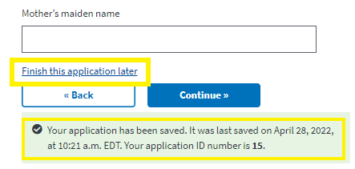

To move forward through the application, the user clicks “Continue.” They cannot move forward until all required information on the page is complete. An example error message is shown below. The user can use the back button to go back to a section of the application.

## Veteran Information

### Veteran information page 1: Names

Authenticated users are shown their name, DOB, and VA service-connected disability rating in a locked state. If they need to update this information, they must contact the VA Benefits Hotline at 800-827-1000.

Authenticated user

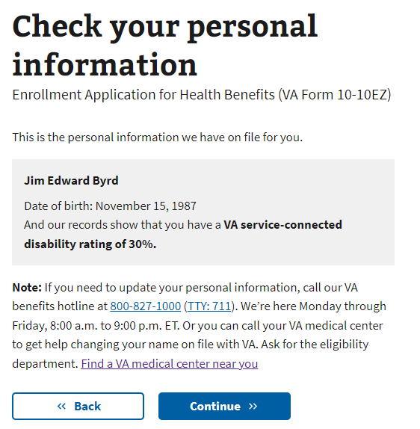

Authenticated users with information in their profile that qualifies them for the shortened form (Veterans with a disability rating of equal to or greater than 50 percent) will be alerted immediately after this page. They may qualify later in the application if they do not see that page, by self-disclosing their rating in another section. These users must input their birthplace and move on to their mother's surname at birth.

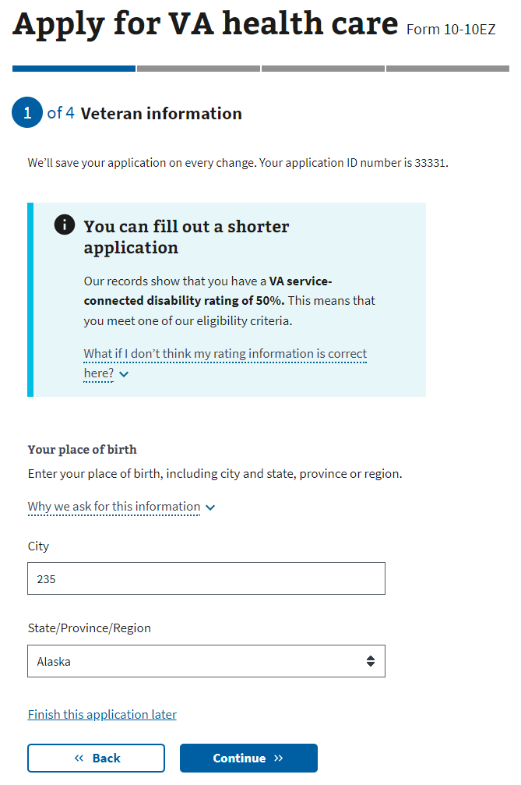

### 

Unauthenticated user

If the user enters their name, DOB, and Social Security number and the data aren’t found in the VA.gov system, the form will display the previously entered name, DOB, and Social Security number.

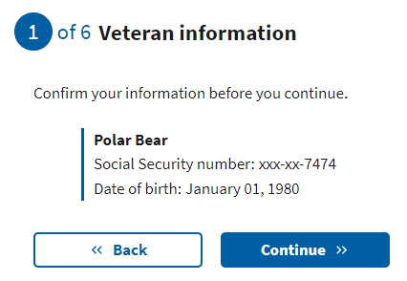

### Veteran information page 4: Place of birth

The user must enter the city name and select the state from the drop-down. This currently doesn’t support international locations. Note: Those born outside the U.S. can enter the city and leave the state blank.

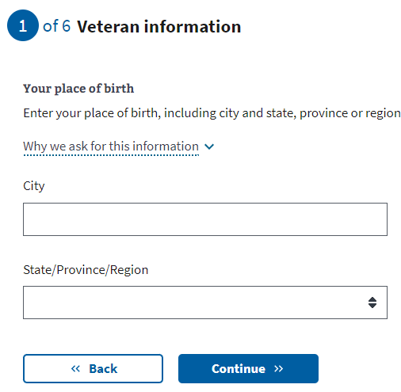

### Veteran information page 5: Mother’s surname at birth

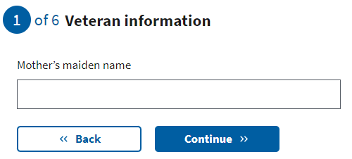

### Veteran information page 6: Birth sex

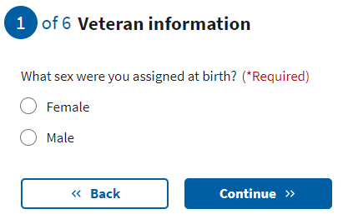

### 

### Veteran information page 7: Race, ethnicity, or origin

The user may select one or more options. This is optional.

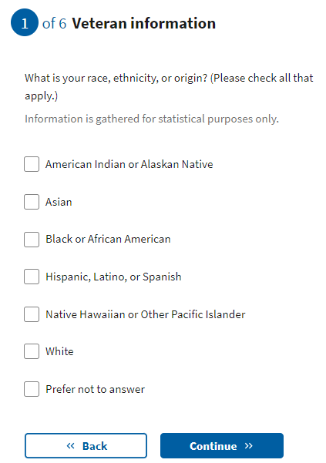

### 

### Veteran information page 8: Mailing address

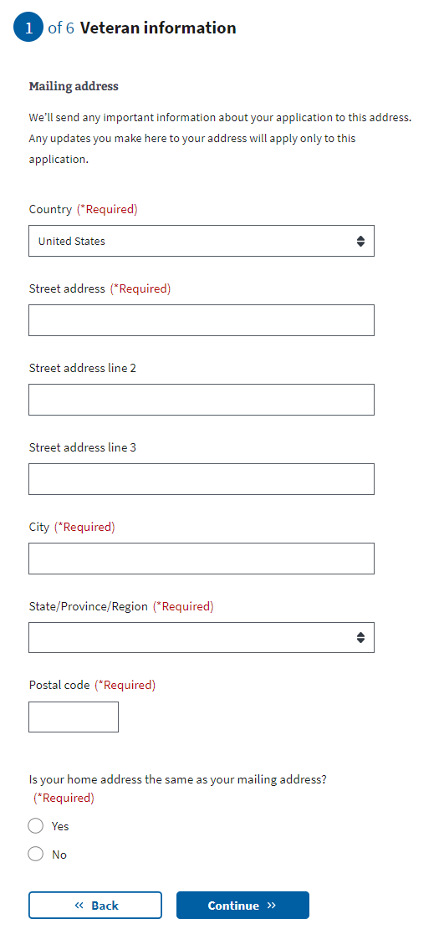

Note: If the user indicates that their mailing address is different from their home address, they will be asked to enter their home address on the following page.

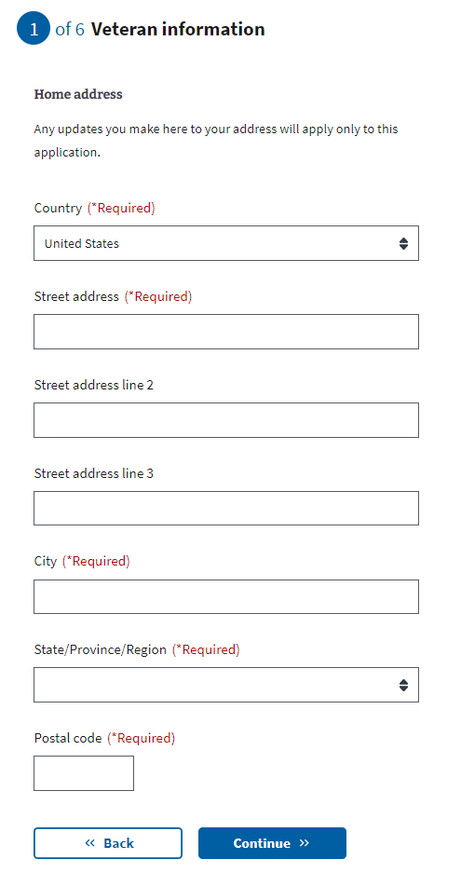

### Veteran information page 9: Email and phone number

Users may provide their email address and home/mobile telephone numbers. If the user decides to share this information, these contact methods will be used to communicate with the Veteran during the application process. If they do not provide either, all communication will be delivered to their mailing address via paper mail.

After this page, users who fill out the short form (Veterans with a disability rating of 50% or higher) will be taken to the military service—toxic exposure section.

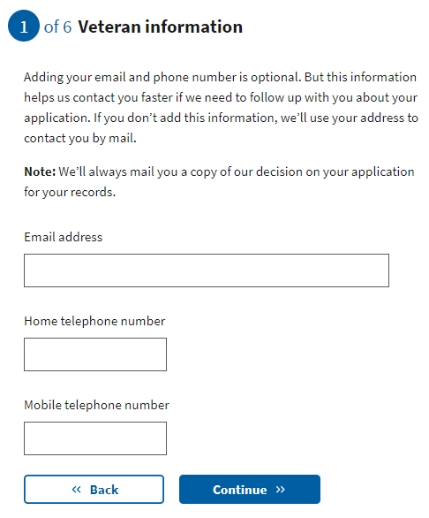

## VA Benefits

### VA benefits page 1: Current compensation from VA

This next section asks for the Veteran’s current compensation based on their service-connected disability rating. The drop-down information shown here explains how we use the information.

This question is not shown to Veterans whose disability rating is already known to the system.

If the Veteran indicates that they do not receive compensation, they will be asked about their VA pension.

If they indicate that they receive compensation for a disability rating of up to 40 percent, they will move on to the next page to enter their military service information.

If the Veteran indicates they receive compensation for a disability rating of 50 percent or higher, they will be redirected to a shortened application version. This shortened form skips the following sections:

1. Military service—branch and service dates
2. Household information

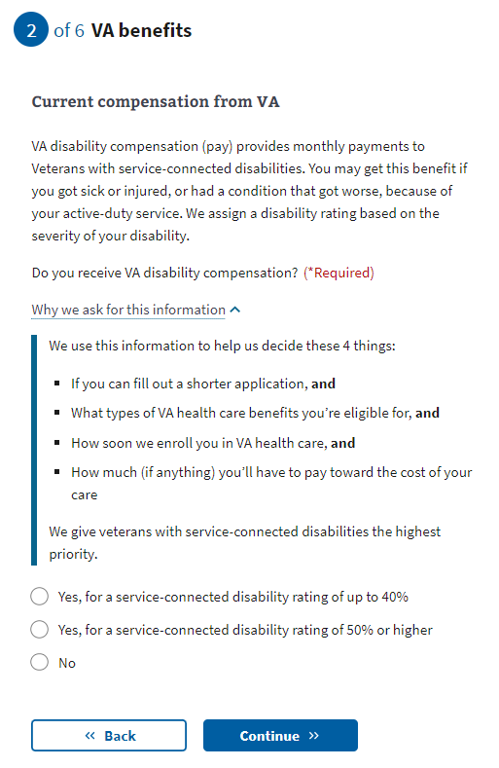

If the Veteran indicates a disability rating of 50 percent or higher, they will be asked to confirm their selection. They will see this page explaining why they need to confirm their selection.

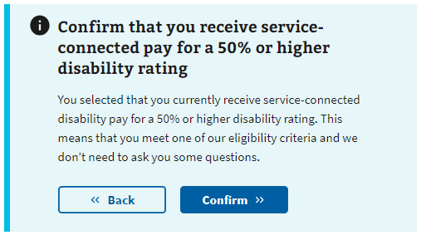

Once they have confirmed they are receiving service-connected pay for a 50 percent or higher disability rating, they will be informed they can fill out the shortened application and explain why. Please proceed to the military service—toxic exposure section.

### VA benefits page 2: Current compensation (Medicaid ineligible)

This question is only shown if the user indicates “No” to the previous VA disability compensation question.

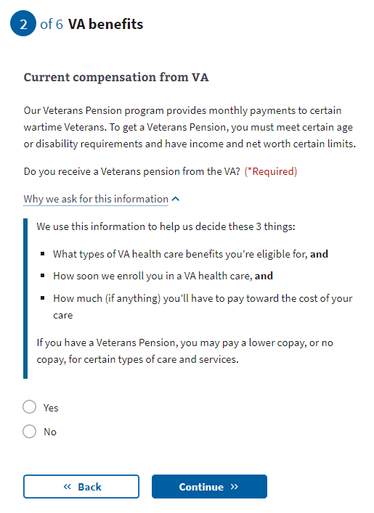

## 

## Military Service

### Military service page 1: Branch and dates of service

The application will check dates to ensure their validity. For example:

* Not 18 years old at input service start date
* Input service end date is before service start date

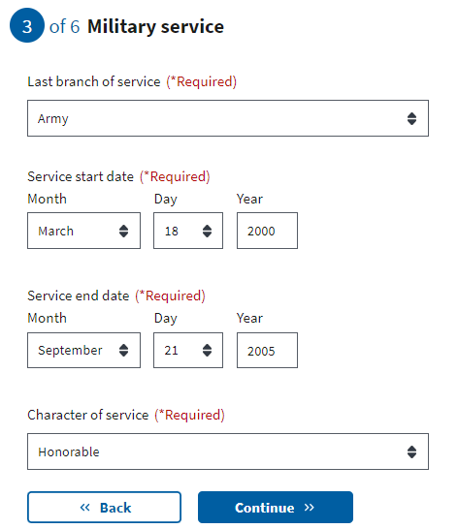

### 

### Military service page 2: Service history

The user may select one or more options. This is optional.

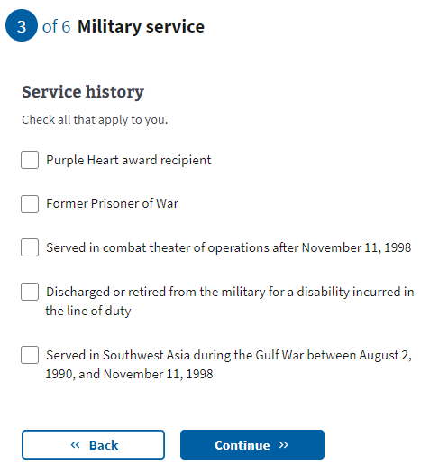

### Military service page 3: Toxic exposure

This page explains toxic exposure and provides resources users might want to access to learn more. A user can choose whether to answer questions regarding military service history and any toxic exposure (or potential toxic exposure). The following questions will ask about specific locations, operations, and toxins where the Veteran may have been exposed.

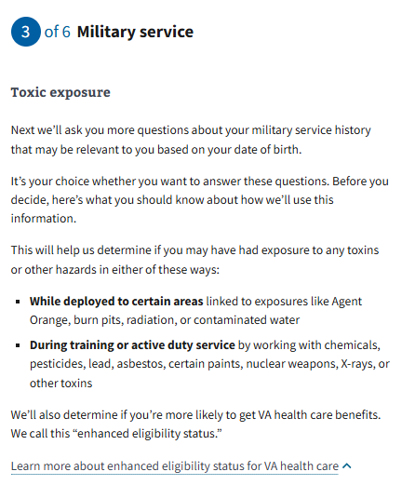

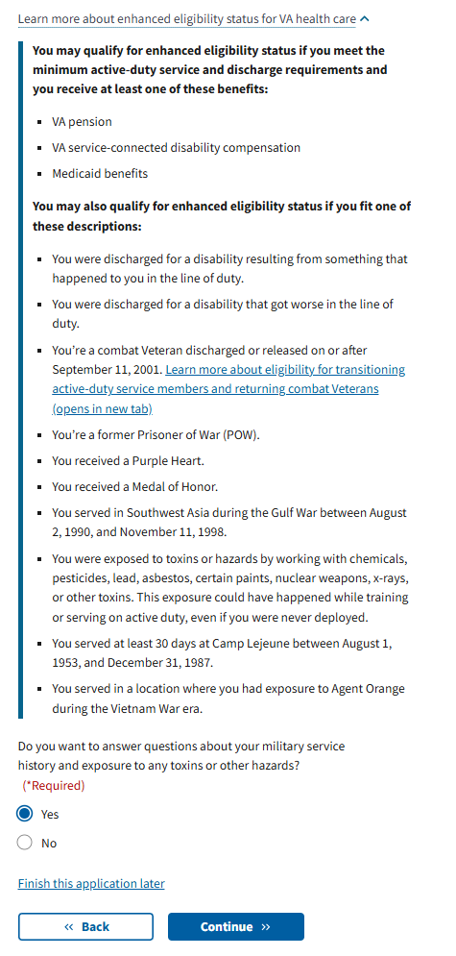

### Military service page 4: Cleanup or response efforts

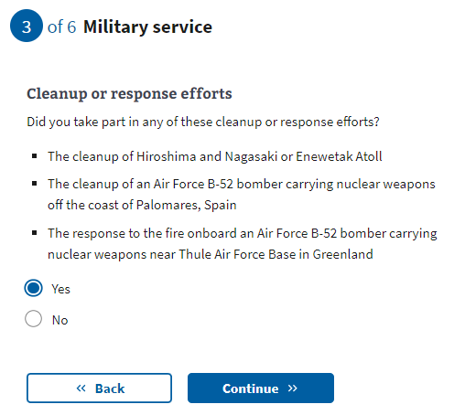

Military service page 5: Service in Gulf War locations

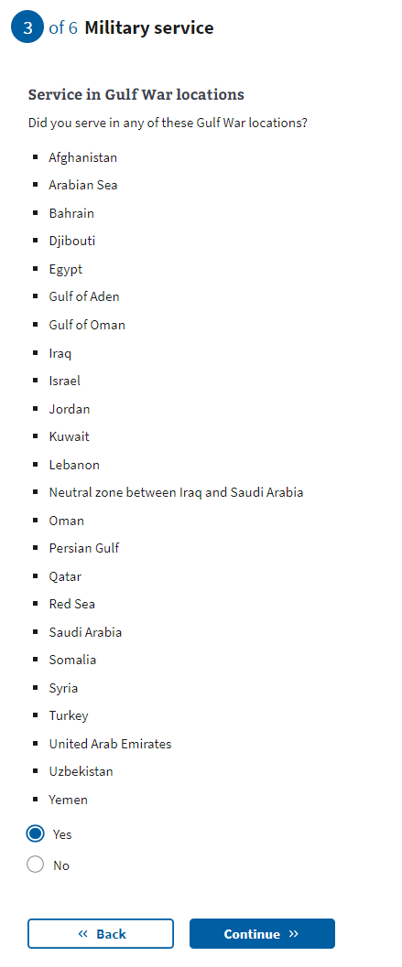

[Military service page 6:](https://docs.google.com/document/d/1q11ictK4zNJR4xZSBCcdndDI_PTItqzqFKfw8N3c1cA/edit?pli=1#bookmark=id.19c6y18) Service dates for Gulf War locations

These date fields are optional. If known, a user can provide a month and year or a date range. If the user does not know or does not want to estimate a date or range, they can leave these optional fields blank and continue to the next page.

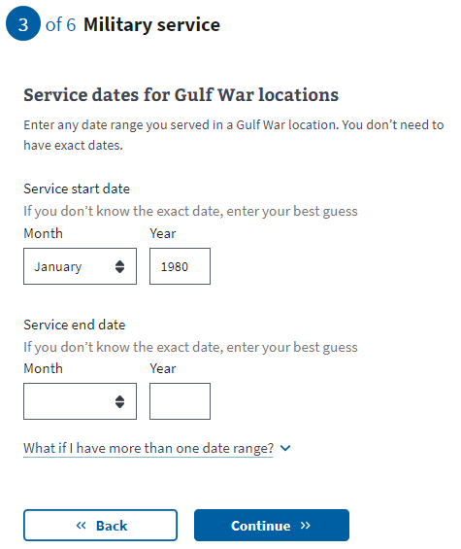

[Military service page 7:](https://docs.google.com/document/d/1q11ictK4zNJR4xZSBCcdndDI_PTItqzqFKfw8N3c1cA/edit?pli=1#bookmark=id.19c6y18) Operations

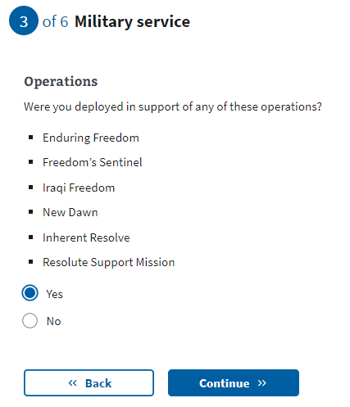

[Military service page 8:](https://docs.google.com/document/d/1q11ictK4zNJR4xZSBCcdndDI_PTItqzqFKfw8N3c1cA/edit?pli=1#bookmark=id.19c6y18) Agent Orange locations

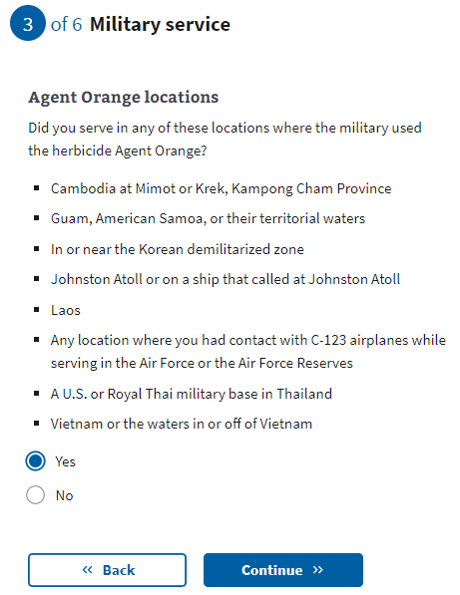

[Military service page 9:](https://docs.google.com/document/d/1q11ictK4zNJR4xZSBCcdndDI_PTItqzqFKfw8N3c1cA/edit?pli=1#bookmark=id.19c6y18) Other toxic exposures

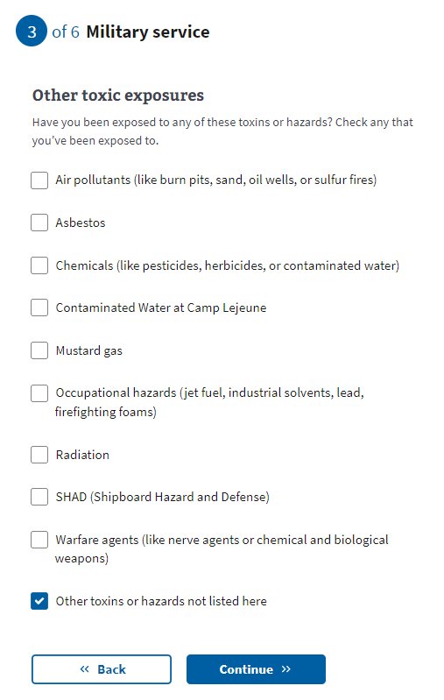

[Military service page 10: Other toxic](https://docs.google.com/document/d/1q11ictK4zNJR4xZSBCcdndDI_PTItqzqFKfw8N3c1cA/edit?pli=1#bookmark=id.19c6y18) exposure

If the user selects “Other toxins or hazards not listed here” from the previous question, they will be asked to list the toxin(s) to which they may have been exposed.

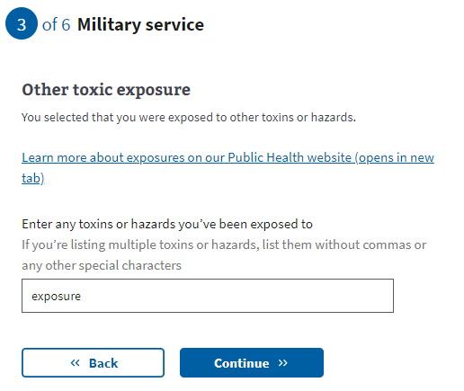

[Military service page 11: Dates of](https://docs.google.com/document/d/1q11ictK4zNJR4xZSBCcdndDI_PTItqzqFKfw8N3c1cA/edit?pli=1#bookmark=id.19c6y18) exposure

These date fields are optional. If the user knows a month and year or a date range, they can provide this information. If the user does not know or does not want to estimate a date or range, they can leave these optional fields blank and continue to the next page.

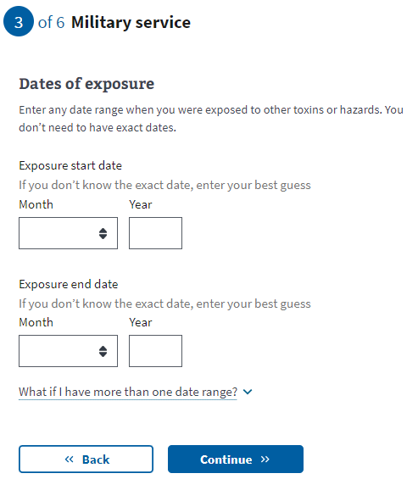

### Military service page 12: Upload discharge papers

A user verified in the VA.gov system will not see this page. Users who have not been verified in the system must upload their DD214 or other discharge documents to help confirm their service. If the Veteran needs to request any of these documents, they can do so here: <https://www.va.gov/records/get-military-service-records/>.

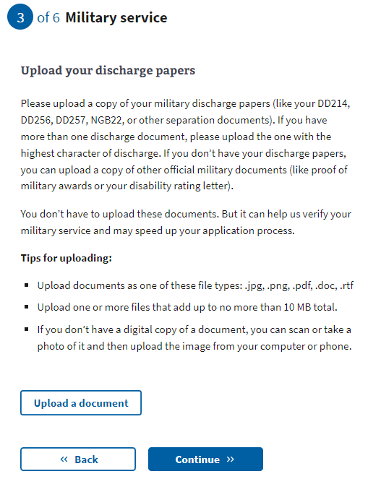

## Household Information

### 

### Household information page 1: Household financial information

This information page explains that financial information is being requested and how it will be used to determine eligibility. It also includes a list of eligibility factors that may be used to determine eligibility.

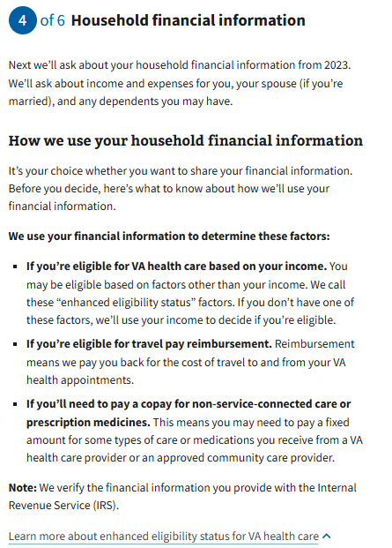

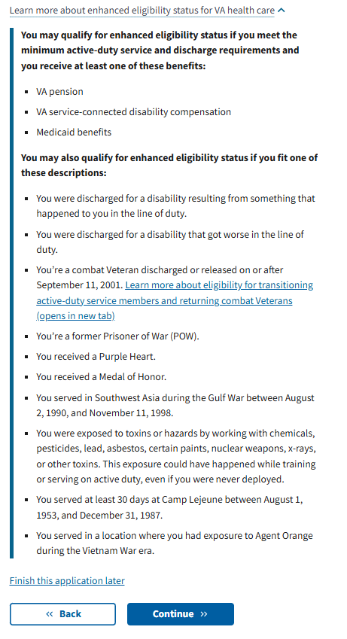

### Household information page 2: Sharing your household financial information

A user can choose whether or not to disclose financial information on this page; however, if the user does not want to provide their financial information and clicks continue, they will be shown the below message:

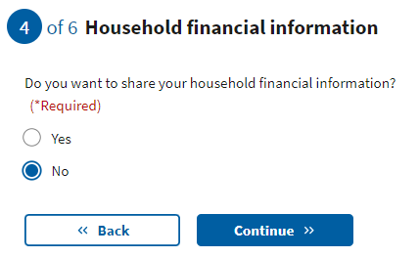

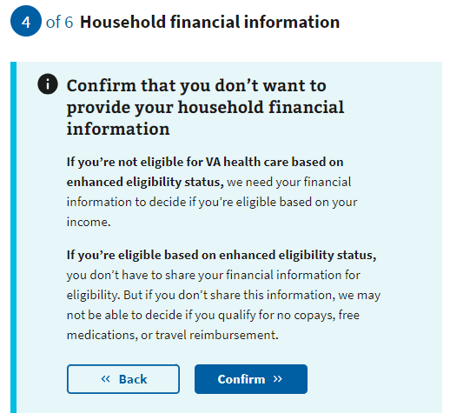

### Household information page 3: Information page

If the user selects “Yes” to provide their financial information, they will see an information page explaining what income and deductibles they must provide.

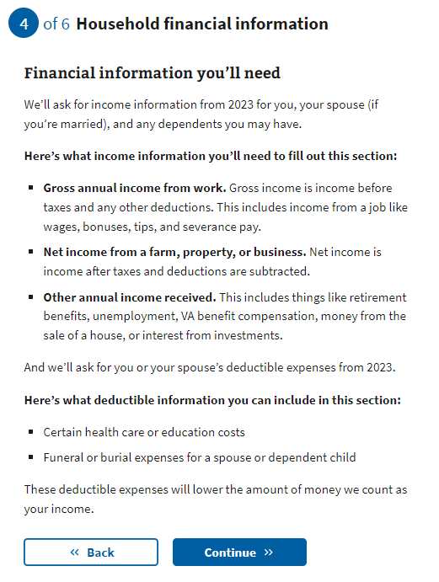

### Household information page 4: Marital status

The user will now need to indicate their marital status from the drop-down.

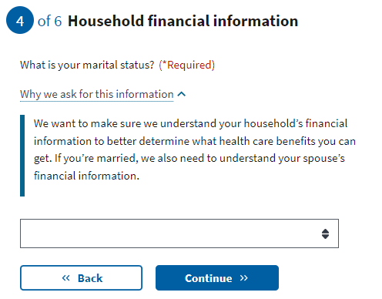

### Household information page 5: Spouse’s personal information

If the Veteran has chosen to share their financial information and indicates they are married or separated, they must fill out their spouse’s information.

If they choose not to disclose their financial information, they will be taken to the insurance information section of the application once they have indicated their marital status.

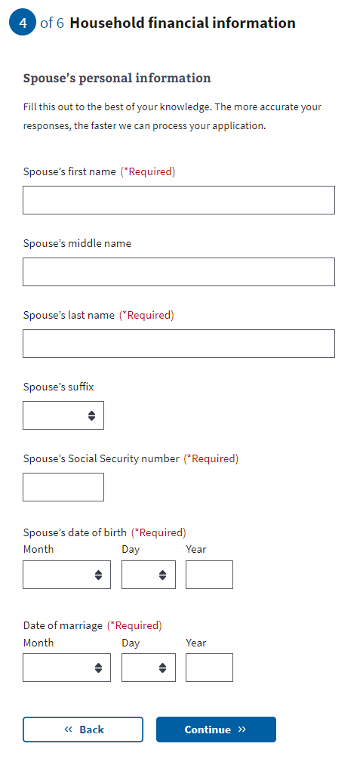

### Household information page 6: Spouse’s additional information

The Veteran will be asked whether their spouse lived with them during the previous year and whether they live with them now. This will help determine whether the spouse should be considered a dependent.

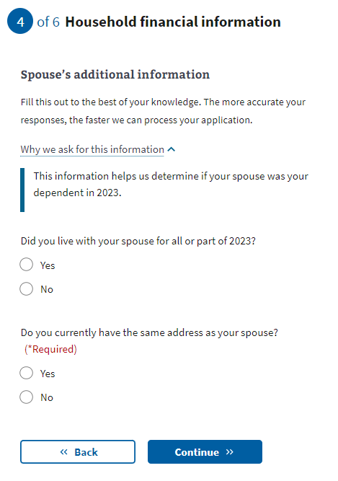

### Household information page 7: Spouse’s financial support

If the Veteran indicates that they did not live with their spouse at any time in the previous year, they will be asked whether they provided financial support to their spouse during that time.

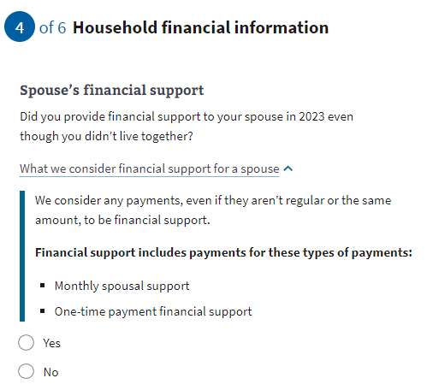

### Household information page 8: Dependent’s information

If the Veteran indicates that they have at least one dependent, the form will ask them to input information about the dependent. They will have the option to enter more than one dependent.

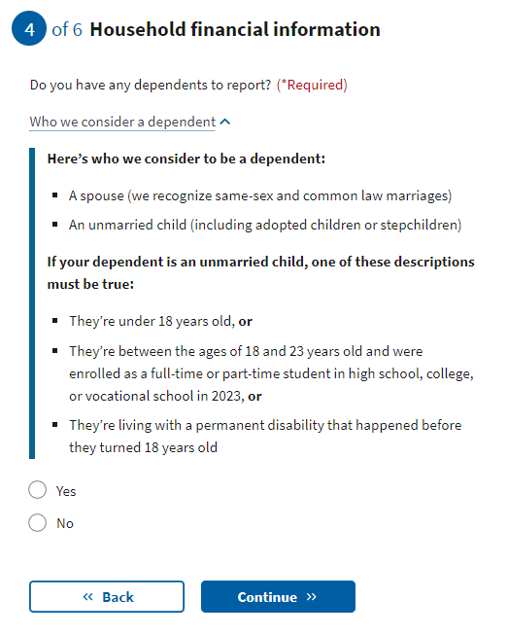

Examples of when someone becomes your dependent:

* Birth of a child: The DOB would be the date the child became your dependent.
* Adoption: The official date of adoption would be the date on which the child became your dependent.

### Household information page 9: Dependent’s personal information The Veteran will be asked to provide the dependent’s information.

### Household information page 10: Dependent’s additional information

The Veteran will be asked whether their dependent was permanently disabled before turning 18 years old, whether they lived with them during the previous year, and if the dependent earned any income during the last year.

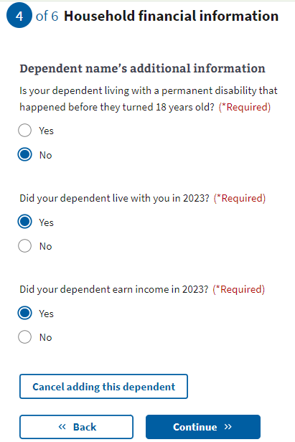

### Household information page 11: Dependent’s annual income (previous year)

If the Veteran indicates their dependent earned income during the previous year, they must provide those income details.

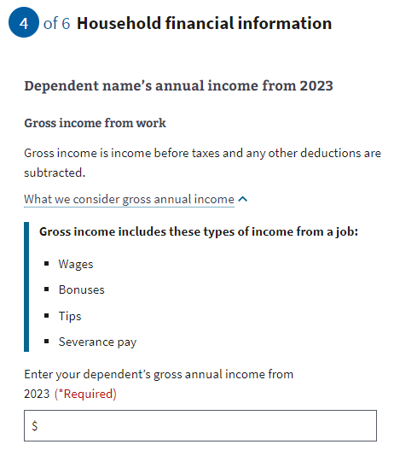

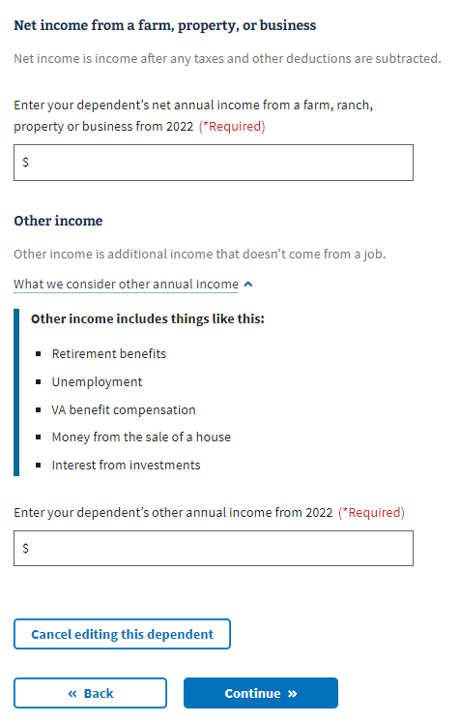

### 

### Household information page 12: Dependent’s education expenses

If the dependent is between the ages of 18 and 24, the Veteran will be asked about education expenses.

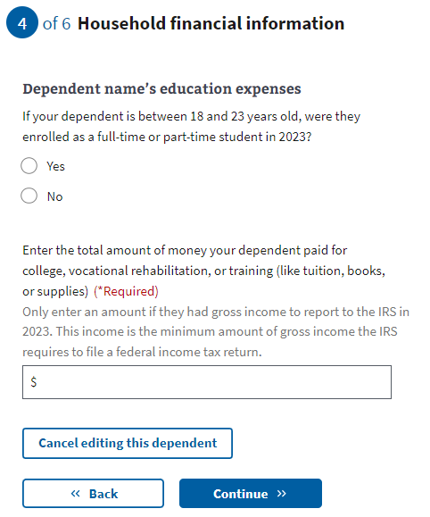

### Household information page 13: Review your dependents

The user can add dependents by answering “Yes” to “Do you have another dependent to report?”

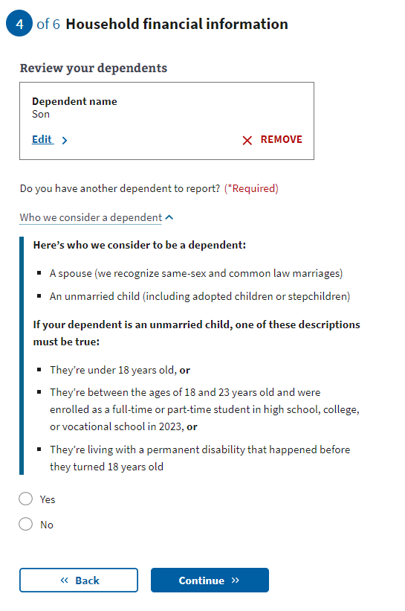

### Household information page 14: Annual income

The user must provide the requested financial information in the following forms. The application will ask about their annual income and the previous year’s deductible expenses. If the Veteran indicated they were married, they will also be asked for their spouse’s annual income.

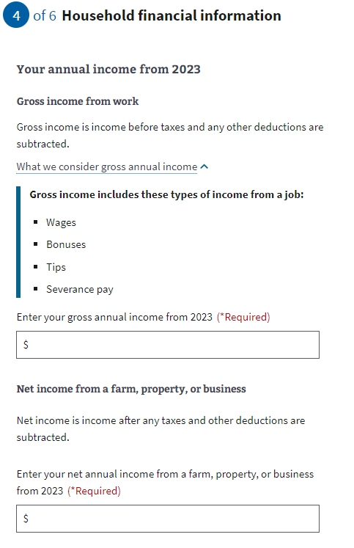

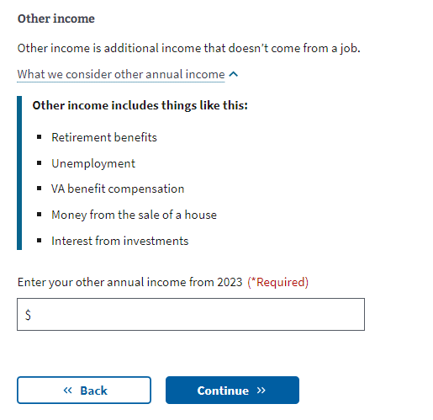

### Household information page 15: Previous calendar year’s deductible expenses

### 

## 

## Insurance Information

### Insurance information page 1: Medicaid

This page is shown to all users. The user needs to indicate whether they’re eligible for Medicaid. Those filling out the shortened application will see an alert on this and all remaining pages indicating that they are filling out a shortened application and why.

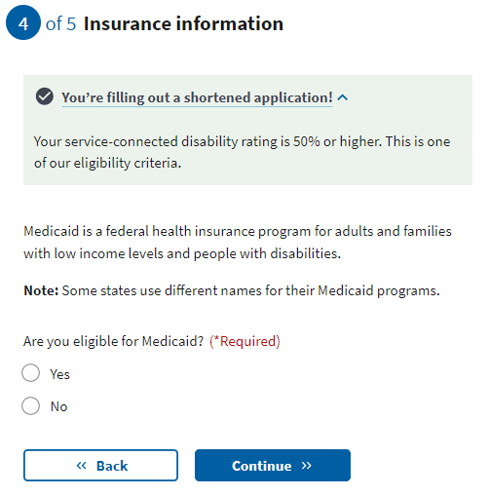

### Insurance information page 2: Medicare

If the user is not eligible for the shortened form, they will be asked about Medicare Part A. The user needs to indicate whether they’re enrolled in Medicare Part A. If they select “Yes,” the next page will request the effective date of their Medicare Part A coverage.

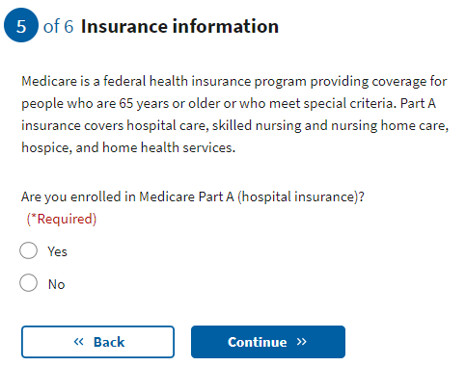

### Insurance information page 3: Medicare detail

The user must input the effective date of their Medicare Part A and their Medicare claim number.

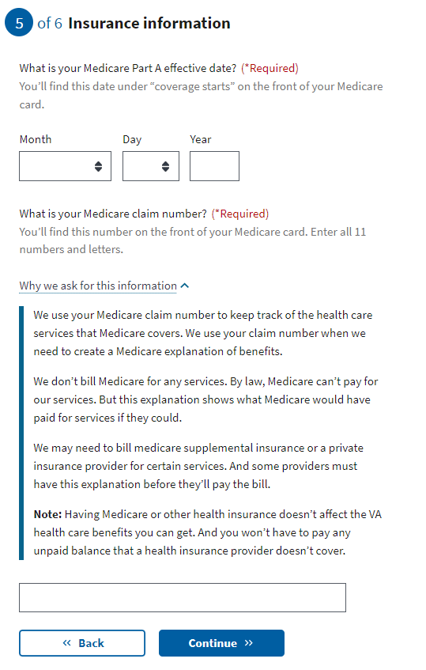

### Insurance information page 4: Other coverage

The user needs to indicate whether they have any additional health insurance coverage. If they do, the form will expand to allow them to input that information.

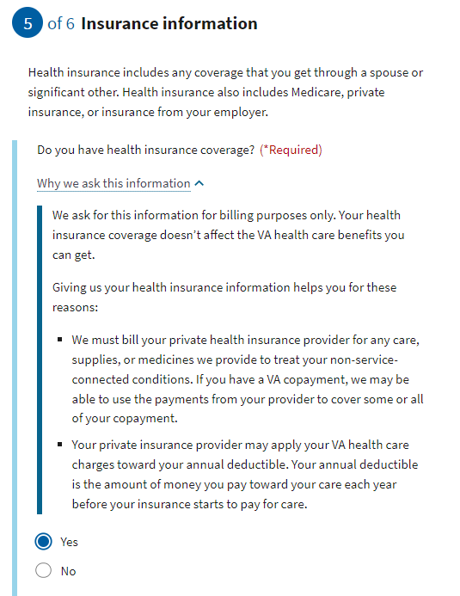

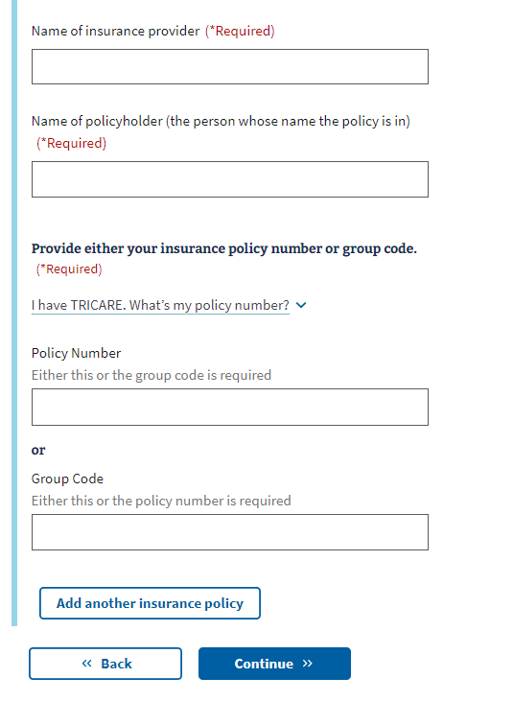

### Insurance information page 5: VA facility

The user must indicate whether they’re applying for minimum essential coverage under the Affordable Care Act. Then, they will select their preferred VA medical facility by choosing the state and facility from the second drop-down menu. If they need assistance locating a facility, they can use the [VA Facility Locator](https://www.va.gov/find-locations) by clicking on the link below the “Center or clinic” drop-down.

The Veteran can indicate whether they want VA to contact them to schedule their first appointment.

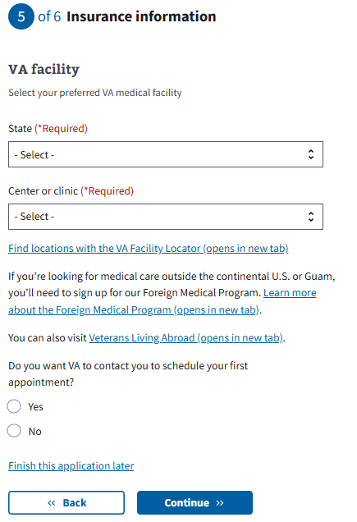

## Review Application

Once the Veteran has completed the application, they will be shown the Review Application section. The user can open each section in this section and see what information they entered.

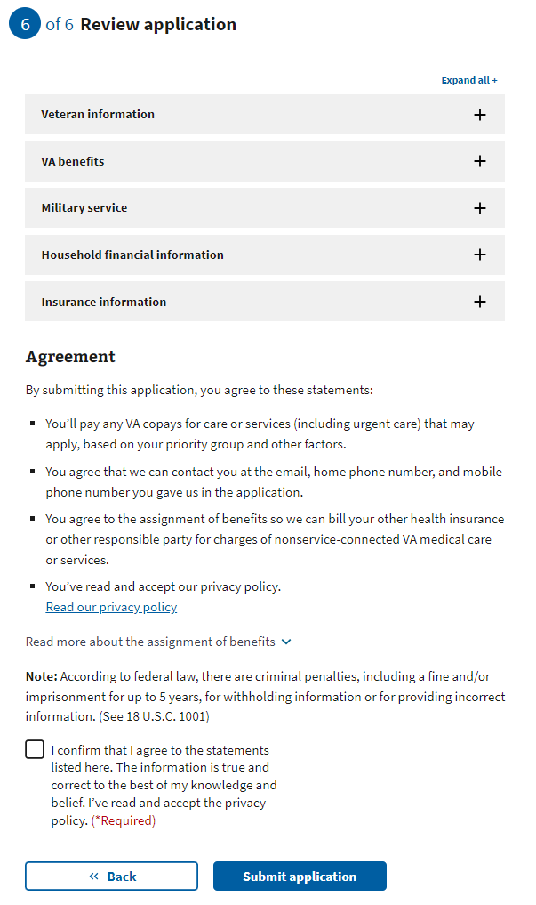

If they want to change the information shown, they can select the “Edit” button and change that information.

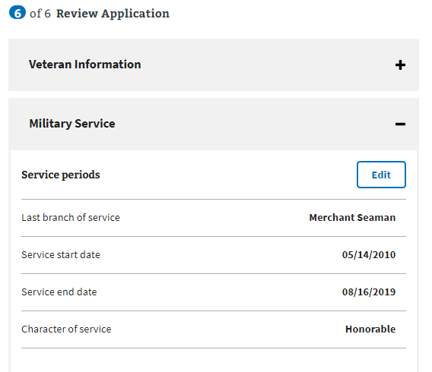

Once the “Edit” button is pressed, the user can update the information in that section. They must also press the “Update Page” button to save the changed information.

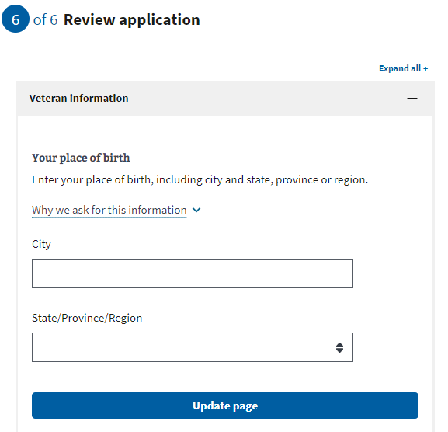

If any of the changes made remove any required information or trigger additional questions that need to be answered, the application will draw their attention to where the update needs to be made.

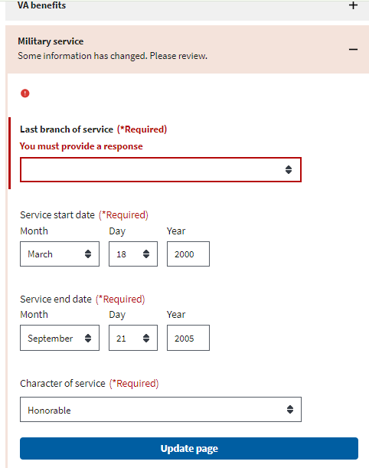

Once the user has reviewed the information and is ready to apply, they must select the check box indicating they agree to the statements listed, that the information is accurate and correct, and that they have read and accepted the privacy policy. The privacy policy can be accessed via the link. This will be opened in a new tab, and their application won’t be interrupted:

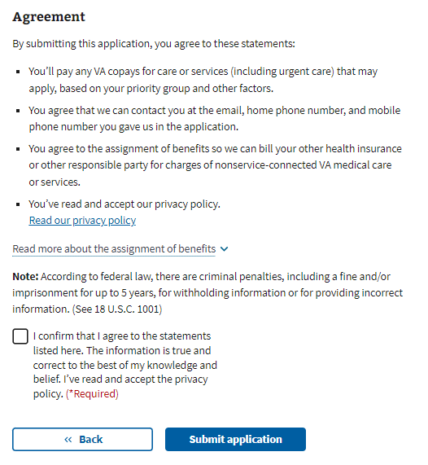

The user will be shown the following information after they submit their application:

